SQL DBMS Assignment

248518 Gaurav B Raskar

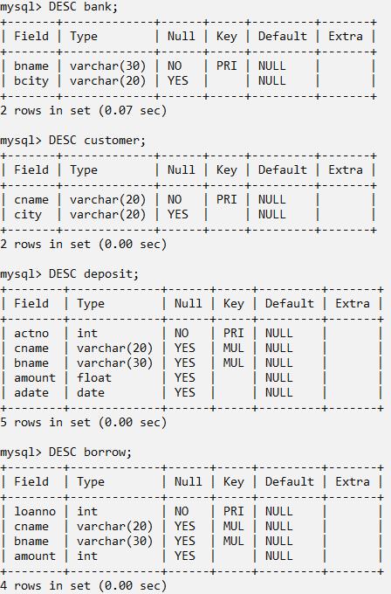

INSERT INTO bank VALUES("AJNI Bank","NAGPUR"),

("ANDHERI Bank","MUMBAI"),

("CHANDANI Bank","DELHI"),

("DHARAMPETH Bank","NAGPUR"),

("M.G.ROAD Bank","BANGALORE"),

("NEHERU PALACE Bank","DELHI"),

("POWAI Bank","MUMBAI"),

("VIRAR Bank","MUMBAI"),

("VRCE Bank","NAGPUR");

INSERT INTO customer VALUES("ANIL","KOLKATA"),

("KRANTI","MUMBAI"),

("MADHURI","NAGPUR"),

("MANDAR","PATANA"),

("MEHUL","BARODA"),

("NAREN","MUMBAI"),

("PRAMOD","NAGPUR"),

("SANDIP","SURAT"),

("SHIVANI","MUMBAI"),

("SUNIL","DELHI");

INSERT INTO deposit VALUES(100,"ANIL","VRCE BANK",1000.00,"1995-03-01"),

(101,"SUNIL","AJNI BANK",5000.00,"1996-01-04"),

(102,"MEHUL","CHANDANI BANK",3500.00,"1995-11-17"),

(103,"PRAMOD","M.G.ROAD BANK",1200.00,"1995-11-17"),

(104,"SANDIP","ANDHERI BANK",3000.00,"1995-03-27"),

(105,"SHIVANI","VIRAR BANK",1000.00,null),

(106,"MADHURI","AJNI BANK",2000.00,"1995-12-05"),

(107,"KRANTI","NEHERU PALACE BANK",5000.00,"1995-07-02"),

(108,"NAREN","POWAI BANK",7000.00,"1995-08-02");

INSERT INTO borrow VALUES(201,"ANIL","VRCE BANK",5000),

(206,"MEHUL","AJNI BANK",1000),

(311,"SUNIL","DHARAMPETH BANK",3000),

(321,"MADHURI","ANDHERI BANK",2000),

(375,"PRAMOD","VIRAR BANK",8000),

(481,"KRANTI","NEHERU PALACE BANK",3000);

Q.1.

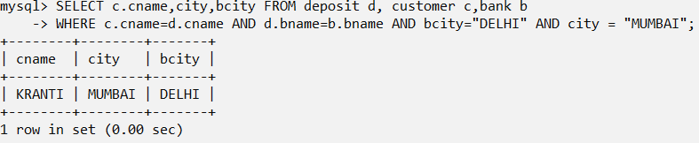

Q.2.  
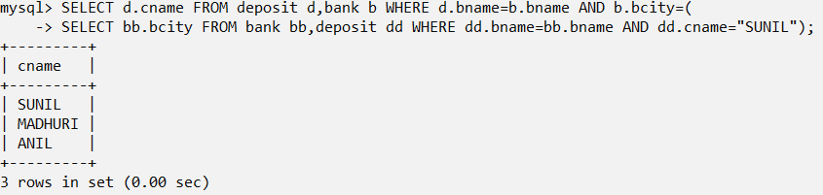

Q.3.

